

M.Sc. Computer Science and Engineering

Hypermedia Applications Project



Chatbot Design

[plug-it.herokuapp.com](http://plug-it.herokuapp.com)

Leoni Luca 10574709

Minotti Luca 10572239

Ratti Francesco 10640265

**GitHub Repository**: [www.github.com/lucagrammer/Plug-IT](http://www.github.com/lucagrammer/Plug-IT)

28th June 2021

Version 1.0

**Abstract**

*This paper represents the first part of the optional work for the Hypermedia Applications course.* The website developed by the Plug-IT group will integrate the Conversational Agent technology.

The Chatbot Design provides the model of the chatbot thought for the Plug-IT website. It is not implemented on the website developed.

**Authors**

**Francesco Ratti**

*MSc Computer Science and Engineering*

[francesco2.ratti@mail.polimi.it](mailto:francesco2.ratti@mail.polimi.it)

+39 3342546426



**Luca Minotti**

*MSc Computer Science and Engineering*

[luca2.minotti@mail.polimi.it](mailto:luca2.minotti@mail.polimi.it)

+39 3315228707



**Luca Leoni**

*MSc Computer Science and Engineering – EIT Digital Human Computer Interaction and Design*

[luca3.leoni@mail.polimi.it](mailto:luca3.leoni@mail.polimi.it)

+39 3484124137



Contents

Introduction 5

Conversational Agent 5

How does Chatbot work? 5

1. Design 6

1.1. Chatbot Design 6

1.1.1. Chatbot Diagram 6

1.1.2 Diagram States 7

1.2 Sequence Diagram 9

1.2.1 First Activity 9

1.2.2 Second Activity 10

1.2.3 Third Activity 11

# Introduction

## Conversational Agent

A conversational agent is a software program which interprets and responds to statements made by users in ordinary natural language. It integrates computational linguistics techniques with communication over the internet.

The Chatbot is an example of Conversational Agent.

## How does Chatbot work?

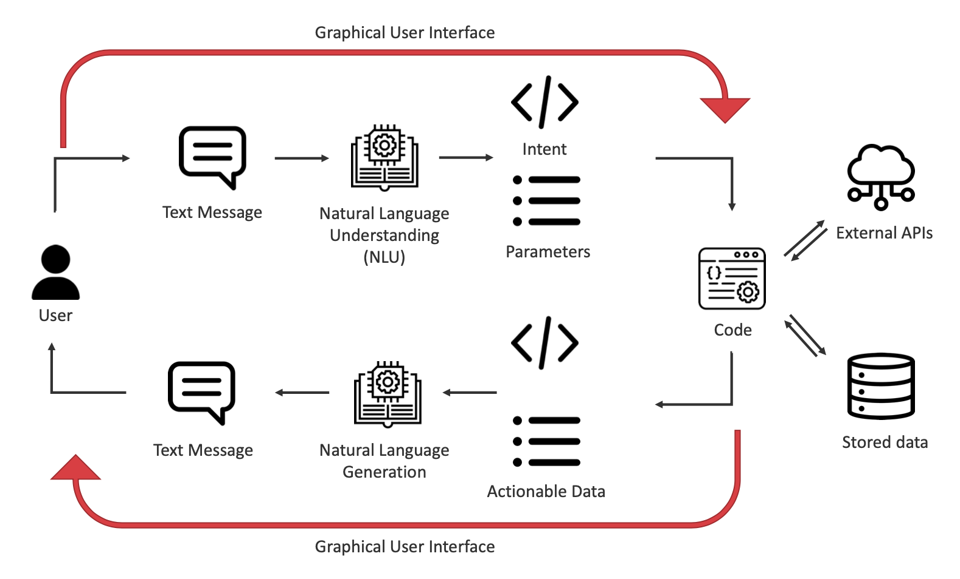

The process starts with the user, that sends a text message through the chat interface. The first unit (*NLU*) is in charge of understand the messages sent by the user. It converts the message from natural language (English, Italian…) into something recognizable by the machine. This conversion process involves advanced technologies. The text is converted in intent and parameters. Intent is what the user wants to say. Parameters are the additional data present in the text.

Now, the backend executes some code, that performs some operations. It can communicate with External APIs and Stored data. Once the code has been executed, it provides some input: actionable data (data required to answer back).

The next step is the Natural Language Generation. This step can be done in different ways:

* *Template based version* (the sentence is already done, and the only operation is to fill the gaps),
* *Generative version* (the machine is trained with lots of complete conversation, so that the *NLG* unit learns how to create sentences).

The text message generated is then sent back to the user.

A multi-modal chatbot creates direct communication between Chat and Interface.

# Design

The design of the chatbot is detailed in this chapter. It provides the description of the process, the related state diagram and an accurate explanation of each state. Finally, it contains some examples of Sequence Diagrams showing the sequence of interactions between user and chatbot.

## Chatbot Design

This chapter describes the design of the chatbot. The first section presents the process and the whole structure of the chatbot. The following sections describe in detail each activity.

### Chatbot Diagram

As shown in the diagram below, the chatbot introduces itself and asks the user whether he/she needs to get support from the company or wants to discover more about *Plug-IT*.

If the user selects the *Support* choice, he/she is asked if he/she prefers to go to the *Support Page (Contacts Page)* or to fulfill the *Support Form (Contacts Form)* directly from the chat. The process ends.

Otherwise, if the user prefers to discover more about *Plug-IT*, the chatbot proposes to see first the company history and then to explore the team or browse among the activities promoted by *Plug-IT*.

If the user selects the guide, the chatbot shows first the *About Page* and then the *People Page*.

On the other hand, if the user selects the second option, the chatbot asks if he/she prefers to see the list of events or the fields in which *Plug-IT* works. The first option brings the user to see the *Introductory Page* of the topic *Event*. Instead, the second option shows first the *Areas Page*, then the *Services Page*. Finally, the chatbot asks the user if he/she wants to contact the company, by showing the *Contacts page*. Otherwise, he/she can contact the company by completing the form in the chat. The process ends.

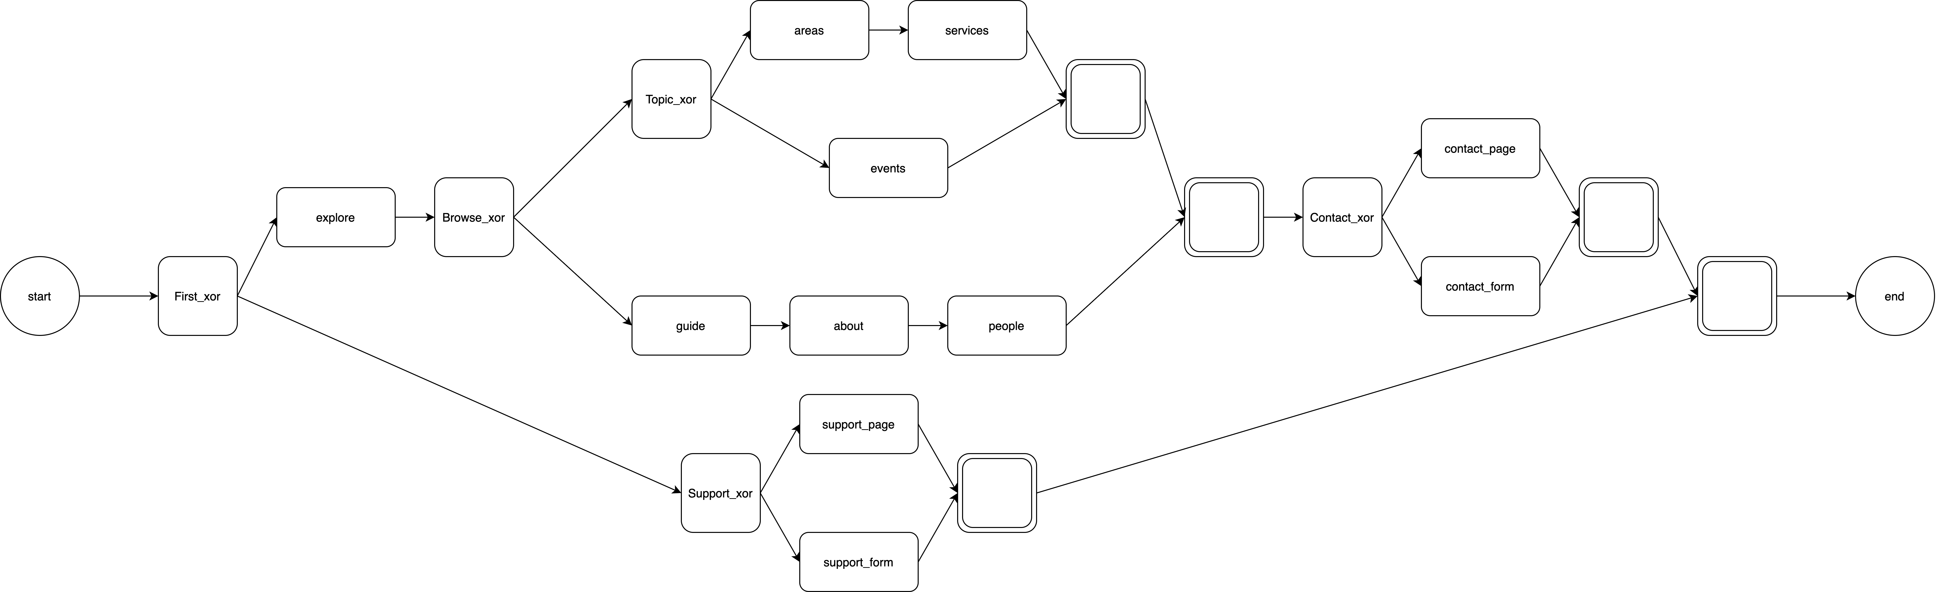

Figure 1: Chatbot Diagram

### 1.1.2 Diagram States

The process represented in *Figure 1* consists of eighteen states. Here below, each of the activity is described in terms of *TYPE*, *BEHAVIOUR* and *NEXT* *STATE*.

#### *Start*

It is the first activity, and it is of type *START*. The callback is *start*. Indeed, this callback must be given to the start activity in the process. After the start, it follows ***First_xor***.

#### *First_xor*

This activity has *XOR* type, which means that one and only one choice can be picked. Specifically, the user is asked to choose whether to directly contact the company or discover more about *Plug-IT*. The callback is generic_xor. The two possible choices are ***Support_xor*** or ***Explore***.

#### *Support_xor*

This activity has *XOR* type, which means that one and only one choice can be picked. Specifically, the user is asked to choose whether he/she wants to go to the Contacts Page or if he/she prefers to fill out the form via the chatbot. The callback is generic_xor. The two possible choices are ***Support_page*** or ***Support*_*form***.

#### *Support_page*

This activity is a *TASK*. It shows the Contacts Page, containing the address of the *Plug-IT* headquarter and a contact form. Both, ***First_xor*** and ***Support_xor*** terminate after the execution of this activity. The next state is ***End***.

#### *Support_form*

This activity is a *TASK*. The user is asked to fill out all the fields in the contact form through the chat. In particular, he/she is asked to write the content of the message also providing his/her name and an email address. Both, ***First_xor*** and ***Support_xor*** terminate after the execution of this activity. The next state is ***End***.

#### *Explore*

This activity is a *TASK*. It simply shows the Homepage of the website. The next state is ***Browse_xor***.

#### *Browse_xor*

This activity has *XOR* type, which means that one and only one choice can be picked. The chatbot asks the user if he/she prefers to read the history of the company and explore the team or if he/she prefers to browse the activities promoted by *Plug-IT.* The possible choices are ***Topic_xor*** or ***Guide***.

#### *Topic_xor*

As the previous one, this activity is a *XOR*. The user is asked to choose whether to see the list of the organized events or the fields in which *Plug-IT* works. The callback is generic_xor. The possible choices are ***Areas*** or ***Events***.

#### *Areas*

This activity is a *TASK*. It shows the page containing all the areas in which Plug-IT works. The next state is ***Services***.

#### *Services*

This activity is a *TASK*. It shows the page containing all the services provided by *Plug-IT.* Both, ***Topic_xor*** and ***Browse_xor*** terminate after the execution of this activity. The following state is ***Contact_xor***.

#### *Events*

This activity is a *TASK*. It shows the page containing all the events in which *Plug-IT* members take part in. Both, ***Topic_xor*** and ***Browse_xor*** terminate after the execution of this activity. The following state is ***Contact_xor***.

#### *Guide*

This activity is a *TASK*. The chatbot explains what the user will browse in the following steps. As soon as the user writes that he/she wants to start the guide, the ***About*** activity is executed.

#### *About*

This activity is a *TASK*. It takes the user to the About Page. The next state is ***People***.

#### *People*

This activity is a *TASK*. It shows the People Introductory Page, where all the employees are listed. The ***Browse_xor*** terminate after the execution of this activity. The following state is ***Contact_xor*.**

#### *Contact_xor*

This activity has *XOR* type, which means that one and only one choice can be picked. Specifically, the user is asked to choose whether he/she wants to go to the Contacts Page or if he/she prefers to fill out the form via the chatbot. The callback is generic_xor. The possible choices are ***Contact_page*** or ***Contact_form***.

#### *Contact_page*

This activity is a *TASK*. It takes the user to the Contacts Page, containing the address of the *Plug-IT* headquarter and a contact form. Both, ***First_xor*** and ***Contact_xor*** terminate after the execution of this activity. The next state is ***End***.

#### *Contact_form*

This activity is a *TASK*. The user is asked to fill in all the fields in the contact form through the chat. In particular, he/she is asked to write the content of the message also providing his/her name and an email address. Both, ***First_xor*** and ***Contact_xor*** terminate after the execution of this activity. The next state is ***End***.

#### *End*

This activity has *END* type. It concludes the process.

## 1.2 Sequence Diagram

This chapter shows three possible flows of interactions between the user and the chatbot. Each of them is presented first with a brief paragraph describing the context and then through the associated sequence diagram.

### 1.2.1 First Activity

**Context:** A user wants to contact the company to ask questions about services lifetime support. The chatbot provide him/her the possibility to fulfil the contact form directly from the chat.

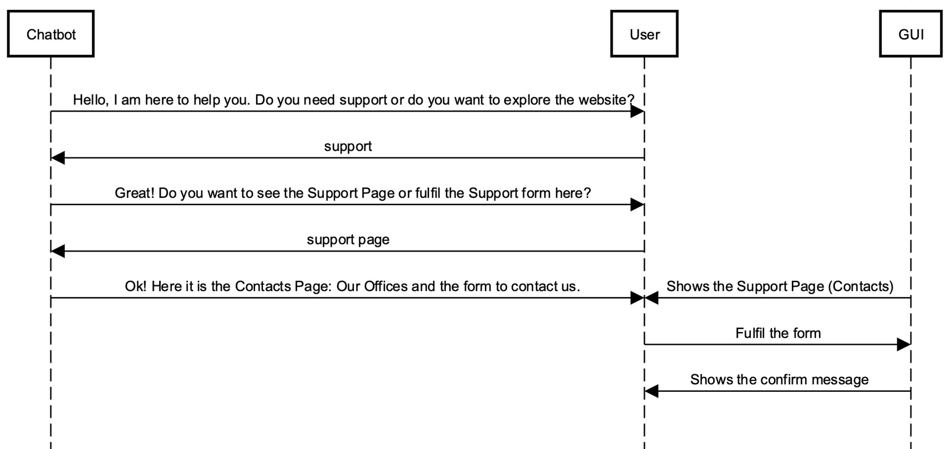

Sequence Diagram 1: First Activity

### 1.2.2 Second Activity

**Context:** A reseller is looking for a partner. He/she want to explore what the Plug-IT universe is. He/she already knows Plug-IT services and he/she knows they will fit his/her customer needs. So, to gather more information about Plug-IT, the chatbot guides him/her through the website, showing the About Page and the People Page. Finally, it brings the user to the Contacts Page, where he/she can complete a form to contact the company.

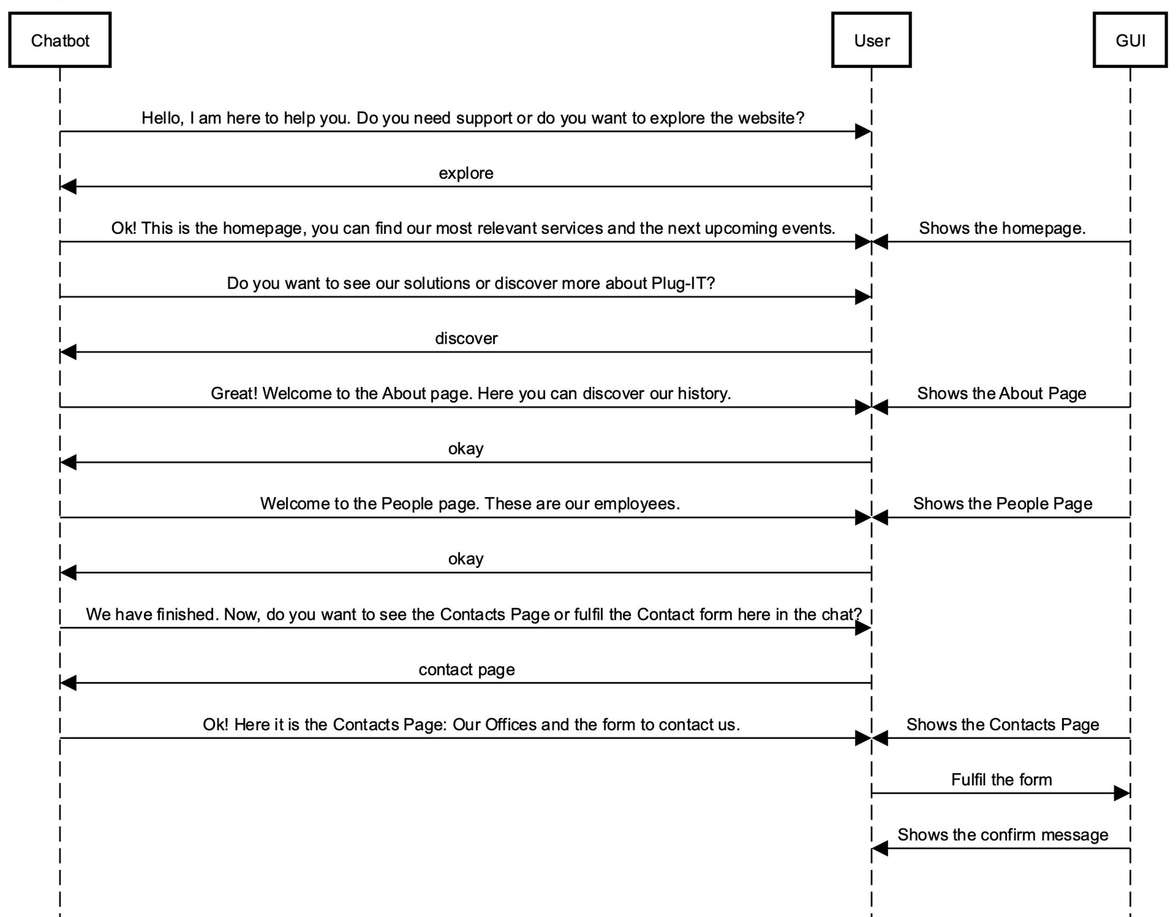

Sequence Diagram 2: Second Activity

### 1.2.3 Third Activity

**Context:** A primary school teacher would like to discover and learn all the features related to Digital Education services. The chatbot guides him/her through the website, showing the Events Page. Here, he/she finds an interesting event, in which some Plug-IT workers will take part in. He/she contacts Plug-IT to retrieve more information.

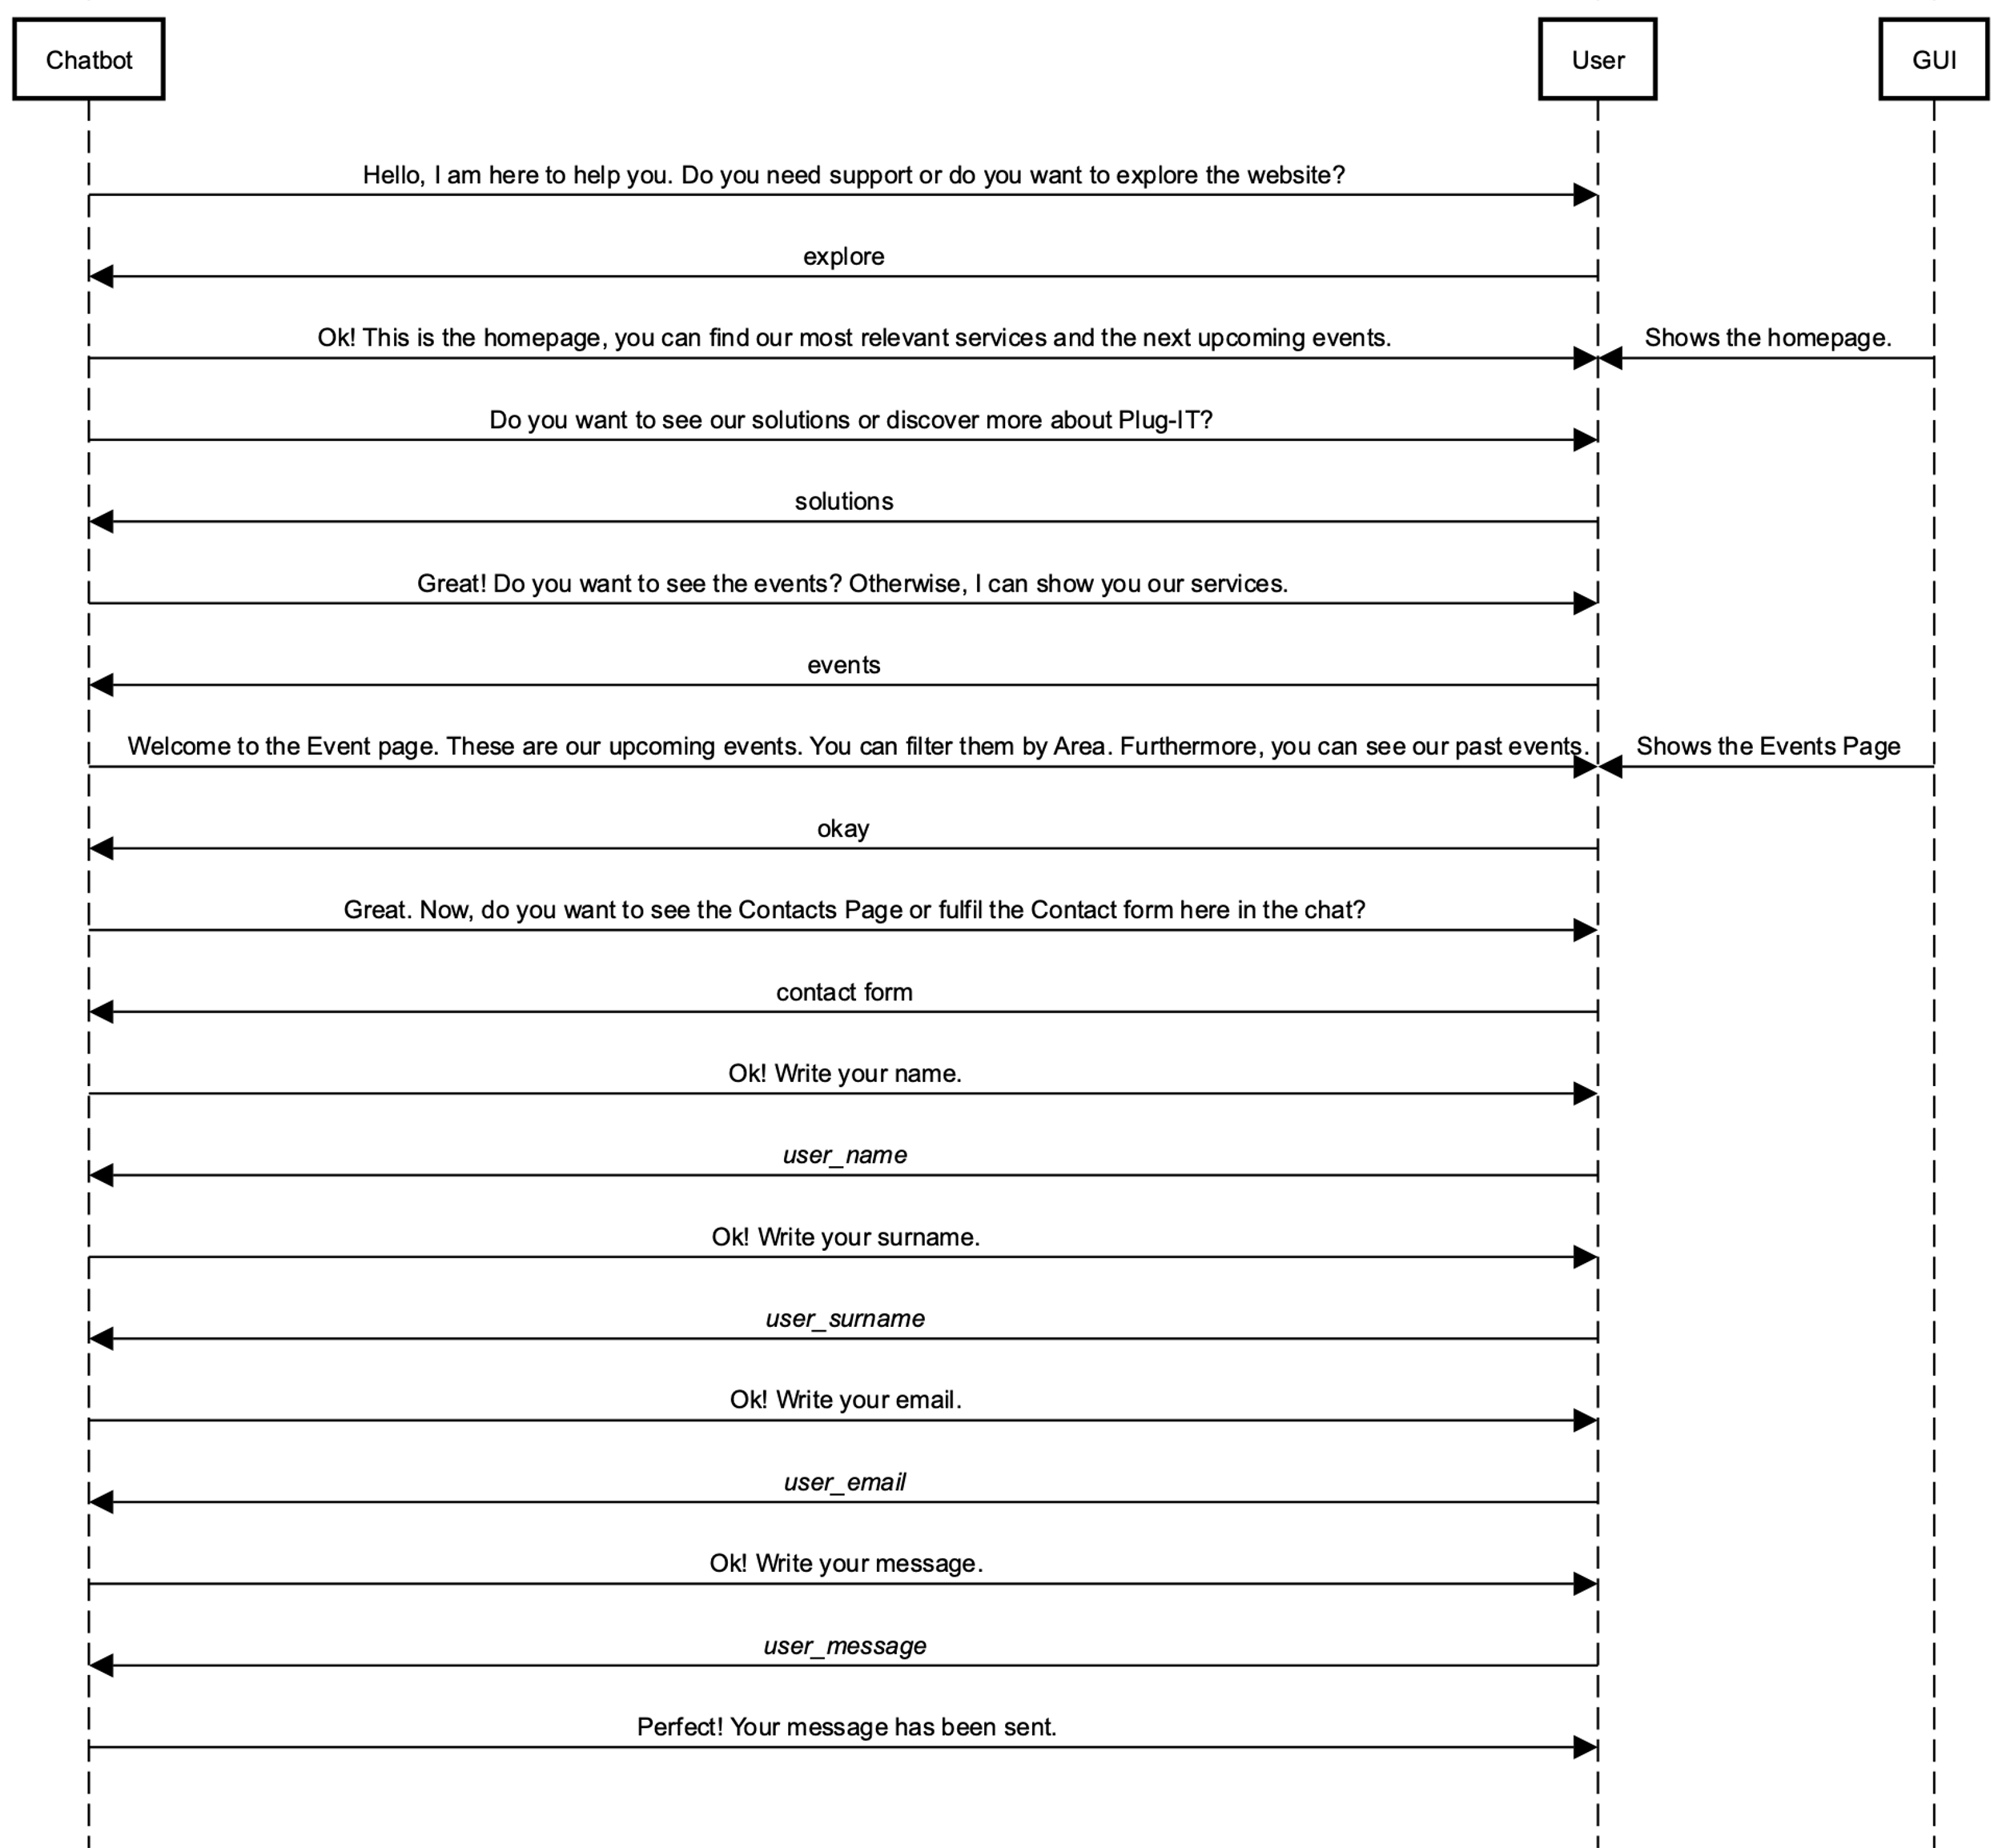

Sequence Diagram 3: Third Activity